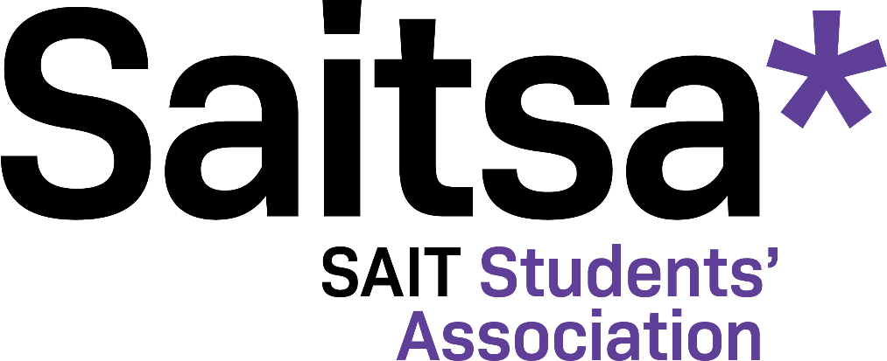

Student Grant Program Policies & Procedures

Created: July 2017
Last Revised: July 2022

Table of Contents
PREAMBLE 3
MISSION 3
VISION 3
DEFINITIONS 3
POLICY STATEMENTS 5
PROCEDURES 4
1.0 Policy Statement 4
2.0. Procedure 5
3.0. Distribution and Reimbursement 6
4.0 Grant Restrictions…………………………………………………………………………………..7
5.0 Selection guidelines………………………………………………………………………………..7

Subject | Approved by: | Approval Date: | Revision Date
Saitsa Student Grant Program | BOD EC | July 10, 2017  July 20, 2017 | July 7th, 2022  October 5, 2020  October 26, 2017,  July 24, 2018,  November 25, 2020

PREAMBLE
In accordance with Board of Directors Policy E-2, Saitsa shall strive to provide students with access to financial resources. To that end, Saitsa believes in supporting students in their pursuit of higher education and passion for learning. Saitsa recognizes that knowledge and skills are not only developed in a classroom setting, but also through various initiatives where students can engage with new materials and network with likeminded individuals. By providing students with funding for conferences, competitions, training, and other events, Saitsa can ensure SAIT students are graduating with the confidence that they will achieve their goals. The Saitsa Student Grant Program seeks to build a community where students can learn, lead, and be exceptional.

MISSION
To provide Saitsa members with the opportunity to participate in professional development, which enhances skillsets, promotes change, cultivates leaders, and fosters new ideas.

VISION
To support Saitsa members in achieving their goals and aspirations.

DEFINITIONS

Academic year
Refers to September 1 to August 31 of any given year.

Event
For consistency, the term ‘event’ shall subsequently refer to any type of professional conference, seminar, training, etc. the applicant is requesting grant funds for.

Graduating Student
Refers to fee-paying members in their final semester immediately prior to graduation.

Grant period
Refers to a specific time period during the academic year when grant applications are accepted and a certain percentage of funding is allocated. These time periods are subject to change each academic year as determined by the Director, Student Services and in consideration of the Saitsa fiscal year. The grant periods are as follows:
July – August September – December January - June

Itemized Receipts
Detailed Receipts submitted for reimbursement must contain the business’ name, date, items purchased, price of each item, total amount of bill and method of payment.

Semester
Refers to the period of time allotted in SAIT’s academic calendar and, in the case of Apprentice programs, refers to their current classroom instruction period.

Saitsa grant program review Committee
Refers to Saitsa staff who have been selected to review applications for the Student Grant Program.

POLICY STATEMENTS
  - The Saitsa Student Grant Program is intended to fund professional development by providing students’ greater opportunity to enhance their own personal skill sets to better align with their professional aspirations. In order to be eligible for the grant, students must be current Saitsa fee-paying members.
  - The Student Grant Program is intended to cover enough expenses to allow the applicant the opportunity to effectively participate in the event(s) they are planning to attend. Each applicant may receive a maximum of $500.00 per academic year.
  - Saitsa appreciates and values all who apply for the grant; however, due to limited funds, the grant will be awarded on a first-come, first-serve basis per grant period until all available funds are exhausted.
  - The Saitsa grant program review committee will review each application and will reserve the right to approve or deny applicants based on eligibility, completeness of the form and available funds.
  - The Student Grant Program will be sufficiently funded each academic year to ensure the program is able to fulfill Saitsa’s Ends policies.

PROCEDURES
Eligibility
- In order to be eligible for the grant, applicants must be Saitsa fee-paying members during the academic year of application submission.
  - Grants may only be used to fund professional development opportunities including but not limited to:
    - Conferences & seminars
    - Case competitions
    - Guest/keynote speaking
    - Industry events
    - Certification training (i.e., first aid, fall prevention, food safety, etc.).
  - Saitsa recognizes the following expenses for reimbursement, including but not limited to:
    - Registration fees (conference or competition fee, certification training fee, etc.)
    - Accommodation (Hotel, hostel, etc.)
    - Travel/transportation to/from the event (Air fare, train or bus ticket, taxi, gas mileage, etc.)
  - Saitsa members may receive up to $500 per academic year. Members may apply multiple times per year, but the total amount received cannot exceed $500 per academic year.
  - Applicants who do not request the full $500 within the two grant periods are eligible to continue applying until the full $500 is exhausted.
  - The amount awarded will be determined by the Grant Program Review Committee, who will review applications on a first-come, first-serve basis per grant period. Applications shall be reviewed in the order they are received until all program funds are exhausted for that grant period. Grant funding will not exceed the budgeted amount.
  - Applicants applying for an event that is hosted within their own city or within a reasonable travel distance shall not be compensated for hotel or travel accommodations.
  - Grant funding shall only be provided for five (5) individuals for one single event. If an entire club should wish to attend an event, it is recommended to seek funding from external funders (i.e. industry).
  - Returning or graduating students are eligible to apply up to four (4) months beyond the completion date of their program.

Application Process
  - Applicants must submit a student grant application form in full, as found on the Saitsa website. Incomplete or incorrectly completed applications will not be accepted.
  - Applicants are required to select a date for their event (in the case multiple dates for training/event, the start date is appropriate).
  - If a successful applicant is unable to attend their approved event and opt to reschedule, they must inform Saitsa. The selection committee may opt to allocate the previously approved funding to the applicant’s rescheduled event date. If denied, the applicant must reapply.
  - If applying as part of a Saitsa-recognized club, each individual member must fill out a separate application form. Forms for multiple applicants will not be accepted.
  - Applications are to be approved once the SAIT Add/Drop deadline for the current semester has passed.

DISTRIBUTION & REIMBURSEMENT
  - The Saitsa Grant Program Review Committee shall review applications on a regular basis.
  - The Saitsa Grant Program Review Committee (or designate) shall notify all applicants of the final decision regarding their application within one (1) week of the decision being made.
  - Unsuccessful applicants are to be informed of the reason(s) for their application being denied.
  - Successful applicants are to be informed of the expectations and requirements of them should they choose to accept the grant.
  - Successful applicants are required to submit itemized detailed receipts for all expenses either in person or electronically.
  - In the case of shared expenses (accommodation, gas, etc.), applicants may submit copies of the detailed receipt for reimbursement but must provide the name of the individual who shared the expense and detail how the expense was shared (percentage/amount paid per person).
  - All associated detailed receipts must be submitted at the same time. Missing or lost receipts and/or failure to provide receipts in the given timeframe may result in the loss of part or all of the grant and ineligibility to access grant funding from Saitsa for the remainder of the academic year.
  - Successful applicants will be strongly encouraged to submit a post-event feedback form online.
  - Only in extenuating circumstances shall funding be provided in advance of the event, as determined by the committee.
  - Successful applicants shall be reimbursed in a manner that is consistent with Saitsa’s accounting practices.
4.0 GRANT RESTRICTIONS
4.1 Grants may not be used for purposes other than the participation in professional development opportunities. Grants cannot be used to fund the following items:
    - Any item that violates Saitsa Bylaws, policies, and procedures
    - Flights or hotels purchased using frequent flyer points
    - Academic credit programs (including tuition, co-op, internships), professional memberships or job interviews
    - Textbooks or course related materials
    - Events that include participation in a social or political protest
    - Food
    - Entertainment purposes
    - Personal items
    - Alcohol, cannabis, or illicit purchases
    - Additional expenses incurred while travelling with family or friends.

  - Grants are only available to registered SAIT students who pay Saitsa membership fees.
  - If the recipient does not comply with the terms on which a fund was made, or if the information provided by the recipient is proven to be false or misleading, Saitsa reserves the right to withhold the grant from the recipient.

5.0 SELECTION GUIDELINES
5.1 Applications for this grant shall be subject to review by the Saitsa grant program review committee.
5.2 In considering applications, the Saitsa grant program selection committee will consider the following criteria:
a) The potential benefits of the event to the professional development to the growth and development of the applicant
b) If the applicant has received previous funding from other sources.

5.3 In selecting successful applicants, emphasis will be placed on the development of one or more of the following types of skills:
a. Conceptual skills such as analytical skills, leadership skills, critical thinking, communication skills, etc.
b. Technical (Hard skills) or industry specific skills that require certification such as CPR training, Food safety training, etc.
c. Interpersonal (Soft skills) such as conflict management and resolution skills, Verbal and Nonverbal communication, time management skills, etc.

